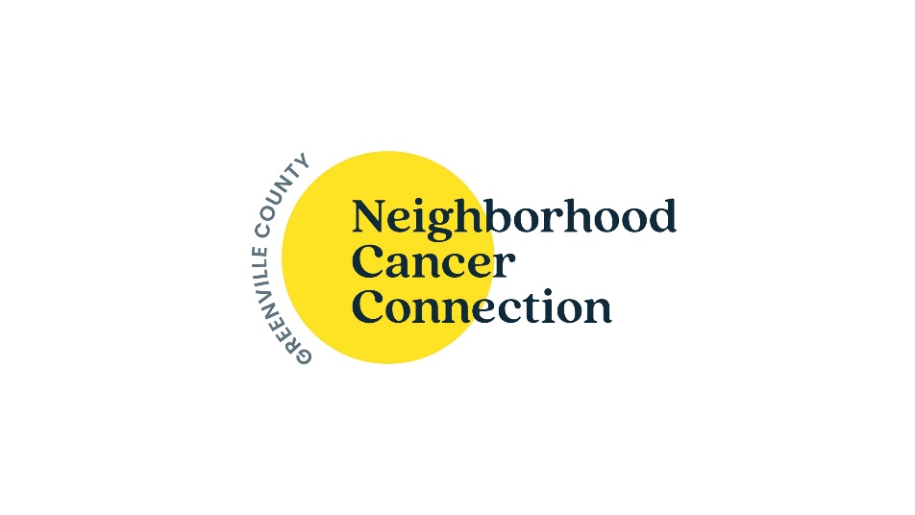

How We Help

Who can become an NCC Client? Anyone currently undergoing cancer treatment (radiation, chemotherapy or immunotherapy) who resides in Greenville or Pickens County. We are on your cancer care team!

How do I become a client? A patient referral must be completed by your oncologist’s office prior to receiving nutritional supplements, disposable items, or financial assistance. Nurse navigators and social workers at your doctor’s office can assist you or we can help you – simply call our office at 864-232-8439.

A referral is not required for mental health services, speaker events, social connection groups, wigs, medical equipment, or ostomy supplies.

What happens next? Once the patient referral is received by our office, a team member may call you to determine how we can best assist you. You are welcome to call or stop by to learn more. Your information is stored in a client management system, and we require an updated patient referral from your oncologist each year.

Services provided at no cost, regardless of income level
- Nutritional supplements and disposable items
- Mental health counseling and support groups for the patient and the caregiver. Adult and pediatric services are available.
- Speaker events and social connection groups
- Wigs, hats, and turbans
- Durable medical equipment (bath assists, canes, walkers, wheelchairs, etc.)
- Ostomy supplies

How do I contact NCC?
113 Mills Avenue Greenville, SC 29605
(864)-232-8439 info@nccgreenville.org www.nccgreenville.org
Monday-Thursday: 8am-4:30pm (closed 12:30-1:30pm)
Friday: 8am-12:30pm

Financial Assistance Services
Financial Assistance is based on eligibility and is not guaranteed. Please contact (864)-236-8890 with questions regarding financial assistance.

- Who is eligible? People whose household income (based on # of people in the household) is 200% of the federal poverty guidelines or lower.

- What am I eligible for? Financial assistance is mainly provided in the form of reimbursement and requires documentation for treatment-related expenses. If you’re eligible, we will pay for:
    - Prescription drugs needed for cancer treatment
($200/mo. cap)
      - Must provide medication sheet that includes patient name, prescriber’s name, date, price, etc. for reimbursement
      - Medications must be written by Oncologist, Oncology Nurse Practitioner, or Palliative Care Doctor
      - Must be turned in within 30 days of expenses incurred
      - Having trouble paying upfront costs? Inquire about our pharmacy programs.
    - Mileage reimbursement to and from cancer treatment
($200/mo. cap)
    - Reimbursement for mileage to/from radiation, chemotherapy, immunotherapy, or oncology visits
    - Must be turned in within 30 days

    - On a limited basis – fuel cards
    - On a limited basis - travel expenses related to out-of-state treatment

    - Utility assistance –including heating/cooling, electricity, water, natural gas
($300 /yr. cap)
    - Must submit a copy of a current and unpaid bill as we pay directly to the utility company. Please note, processing and delivery times can vary by utility company.

How long am I eligible? We’re here to help while you are in active treatment for cancer. If you have questions regarding eligibility, please contact us at (864)-232-8439.

